Tables made:

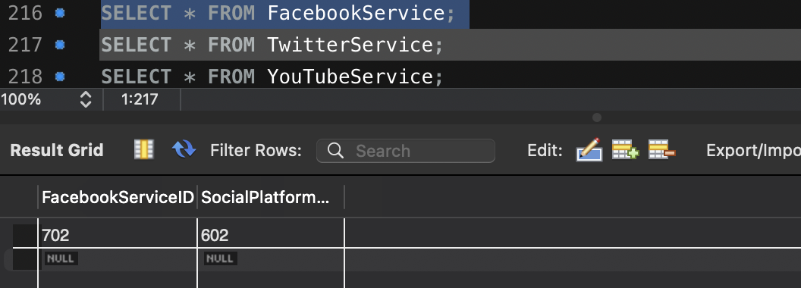

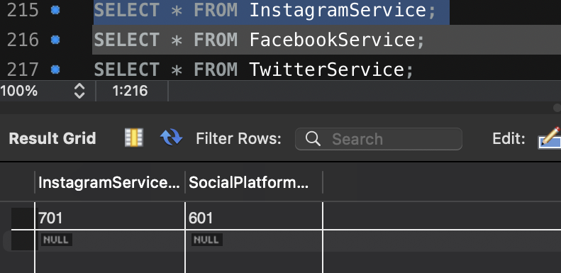

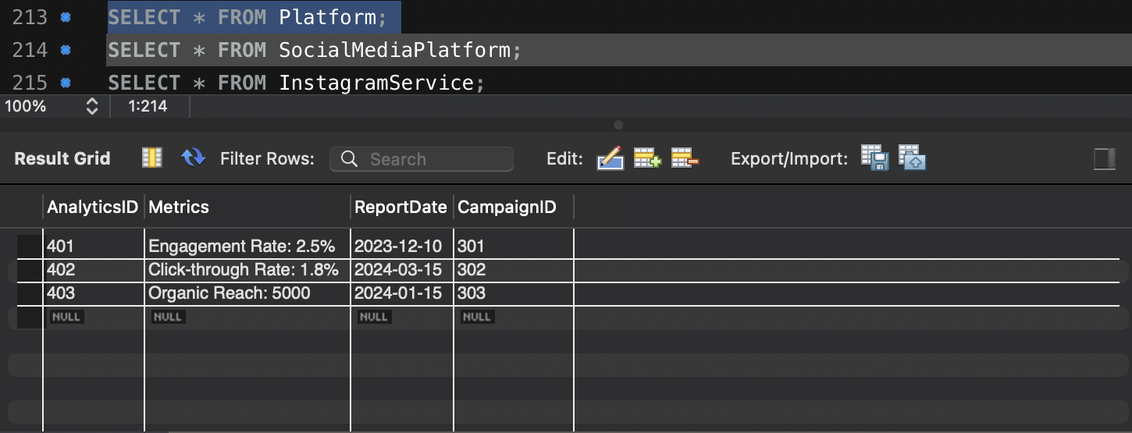

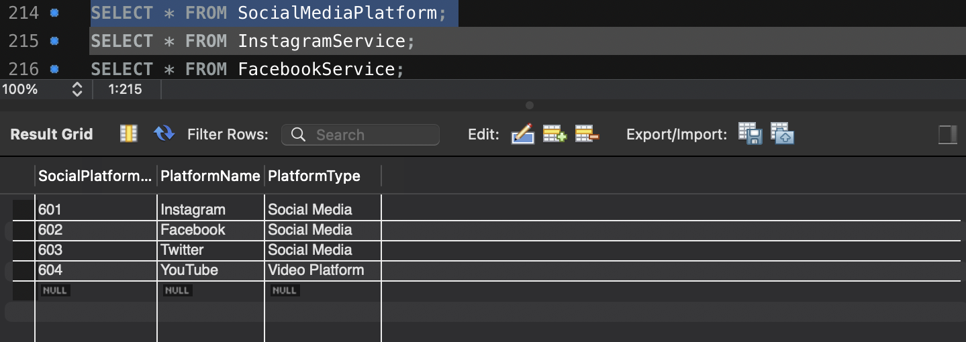

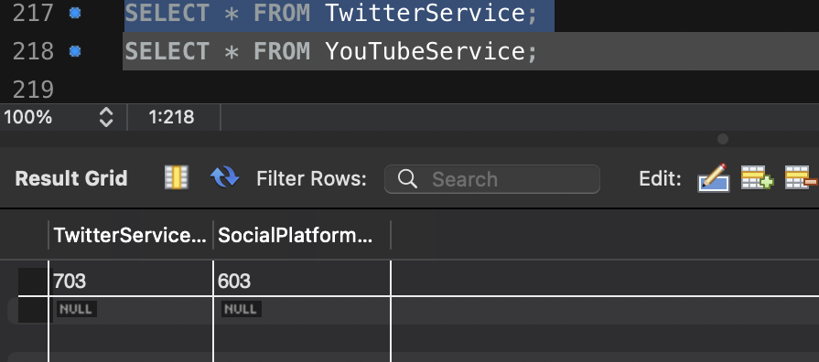

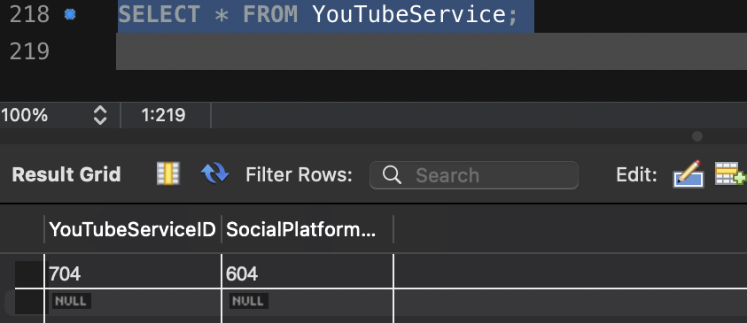

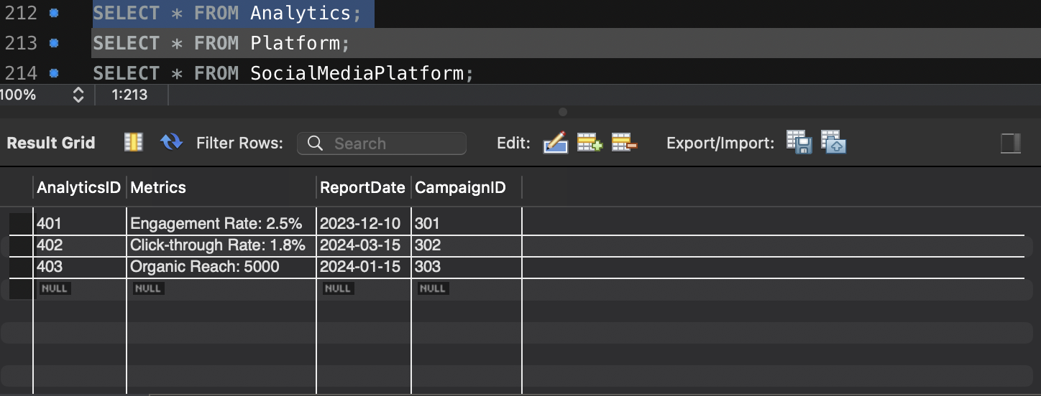

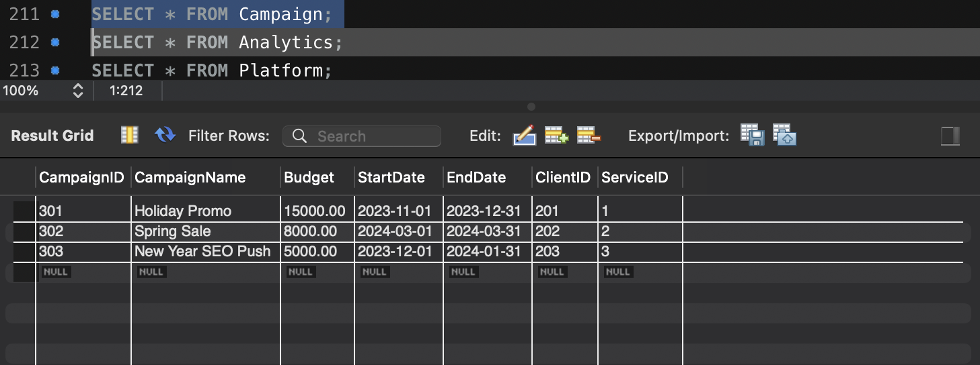

CREATE TABLE DigitalMarketingService (

ServiceID INT PRIMARY KEY,

ServiceName VARCHAR(255) NOT NULL,

Description TEXT

);

-- Table for service types (e.g., Instagram Marketing, Facebook Ads)

CREATE TABLE ServiceType (

TypeID INT PRIMARY KEY,

TypeName VARCHAR(255) NOT NULL,

Description TEXT,

ServiceID INT,

FOREIGN KEY (ServiceID) REFERENCES DigitalMarketingService(ServiceID)

);

-- Table for clients

CREATE TABLE Client (

ClientID INT PRIMARY KEY,

ClientName VARCHAR(255) NOT NULL,

ContactInfo VARCHAR(255),

ServiceID INT,

FOREIGN KEY (ServiceID) REFERENCES DigitalMarketingService(ServiceID)

);

-- Table for marketing campaigns

CREATE TABLE Campaign (

CampaignID INT PRIMARY KEY,

CampaignName VARCHAR(255) NOT NULL,

Budget DECIMAL(10, 2),

StartDate DATE,

EndDate DATE,

ClientID INT,

ServiceID INT,

FOREIGN KEY (ClientID) REFERENCES Client(ClientID),

FOREIGN KEY (ServiceID) REFERENCES DigitalMarketingService(ServiceID)

);

-- Table for campaign analytics

CREATE TABLE Analytics (

AnalyticsID INT PRIMARY KEY,

Metrics VARCHAR(255),

ReportDate DATE,

CampaignID INT,

FOREIGN KEY (CampaignID) REFERENCES Campaign(CampaignID)

);

-- Table for platforms (e.g., Instagram, Facebook)

CREATE TABLE Platform (

PlatformID INT PRIMARY KEY,

PlatformName VARCHAR(255) NOT NULL,

CampaignID INT,

FOREIGN KEY (CampaignID) REFERENCES Campaign(CampaignID)

);

-- Table for social media platforms (Instagram, Facebook, Twitter, YouTube)

CREATE TABLE SocialMediaPlatform (

SocialPlatformID INT PRIMARY KEY,

PlatformName VARCHAR(255) NOT NULL,

PlatformType VARCHAR(255)

);

-- Specific table for Instagram services

CREATE TABLE InstagramService (

InstagramServiceID INT PRIMARY KEY,

SocialPlatformID INT,

FOREIGN KEY (SocialPlatformID) REFERENCES SocialMediaPlatform(SocialPlatformID)

);

-- Specific table for Facebook services

CREATE TABLE FacebookService (

FacebookServiceID INT PRIMARY KEY,

SocialPlatformID INT,

FOREIGN KEY (SocialPlatformID) REFERENCES SocialMediaPlatform(SocialPlatformID)

);

-- Specific table for Twitter services

CREATE TABLE TwitterService (

TwitterServiceID INT PRIMARY KEY,

SocialPlatformID INT,

FOREIGN KEY (SocialPlatformID) REFERENCES SocialMediaPlatform(SocialPlatformID)

);

-- Specific table for YouTube services

CREATE TABLE YouTubeService (

YouTubeServiceID INT PRIMARY KEY,

SocialPlatformID INT,

FOREIGN KEY (SocialPlatformID) REFERENCES SocialMediaPlatform(SocialPlatformID)

);

-- Insert data into DigitalMarketingService

INSERT INTO DigitalMarketingService (ServiceID, ServiceName, Description) VALUES

(1, 'Social Media Management', 'Handles social media presence for businesses'),

(2, 'Content Marketing', 'Creates and distributes valuable content'),

(3, 'SEO Optimization', 'Improves search engine ranking');

-- Insert data into ServiceType

INSERT INTO ServiceType (TypeID, TypeName, Description, ServiceID) VALUES

(101, 'Instagram Marketing', 'Posts, Stories, Ads', 1),

(102, 'Facebook Ads', 'Sponsored posts and targeted ads', 1),

(103, 'Twitter Promotion', 'Engagement and trends', 1),

(104, 'YouTube Ads', 'Video ads for products', 2);

-- Insert data into Client

INSERT INTO Client (ClientID, ClientName, ContactInfo, ServiceID) VALUES

(201, 'TechCorp', 'contact@techcorp.com', 1),

(202, 'GreenHome Solutions', 'info@greenhome.com', 2),

(203, 'PetLand', 'support@petland.com', 3);

-- Insert data into Campaign

INSERT INTO Campaign (CampaignID, CampaignName, Budget, StartDate, EndDate, ClientID, ServiceID) VALUES

(301, 'Holiday Promo', 15000, '2023-11-01', '2023-12-31', 201, 1),

(302, 'Spring Sale', 8000, '2024-03-01', '2024-03-31', 202, 2),

(303, 'New Year SEO Push', 5000, '2023-12-01', '2024-01-31', 203, 3);

-- Insert data into Analytics

INSERT INTO Analytics (AnalyticsID, Metrics, ReportDate, CampaignID) VALUES

(401, 'Engagement Rate: 2.5%', '2023-12-10', 301),

(402, 'Click-through Rate: 1.8%', '2024-03-15', 302),

(403, 'Organic Reach: 5000', '2024-01-15', 303);

-- Insert data into Platform

INSERT INTO Platform (PlatformID, PlatformName, CampaignID) VALUES

(501, 'Instagram', 301),

(502, 'Facebook', 302),

(503, 'Google', 303);

-- Insert data into SocialMediaPlatform

INSERT INTO SocialMediaPlatform (SocialPlatformID, PlatformName, PlatformType) VALUES

(601, 'Instagram', 'Social Media'),

(602, 'Facebook', 'Social Media'),

(603, 'Twitter', 'Social Media'),

(604, 'YouTube', 'Video Platform');

-- Insert data into InstagramService

INSERT INTO InstagramService (InstagramServiceID, SocialPlatformID) VALUES

(701, 601);

-- Insert data into FacebookService

INSERT INTO FacebookService (FacebookServiceID, SocialPlatformID) VALUES

(702, 602);

-- Insert data into TwitterService

INSERT INTO TwitterService (TwitterServiceID, SocialPlatformID) VALUES

(703, 603);

-- Insert data into YouTubeService

INSERT INTO YouTubeService (YouTubeServiceID, SocialPlatformID) VALUES

(704, 604);

-- Insert data into DigitalMarketingService table

INSERT INTO DigitalMarketingService (ServiceID, ServiceName, Description) VALUES

(1, 'Social Media Management', 'Manage social media presence for brands'),

(2, 'Content Marketing', 'Develop and distribute engaging content'),

(3, 'SEO Optimization', 'Enhance search engine visibility');

-- Insert data into ServiceType table

INSERT INTO ServiceType (TypeID, TypeName, Description, ServiceID) VALUES

(101, 'Instagram Engagement', 'Daily posts and stories', 1),

(102, 'Facebook Ads', 'Run targeted ad campaigns', 1),

(103, 'Twitter Trends', 'Engage with trending hashtags', 1),

(104, 'YouTube Video Marketing', 'Create and promote video ads', 2);

-- Insert data into Client table

INSERT INTO Client (ClientID, ClientName, ContactInfo, ServiceID) VALUES

(201, 'TechInnovate', 'contact@techinnovate.com', 1),

(202, 'GreenSolutions', 'info@greensolutions.com', 2),

(203, 'PetCarePlus', 'support@petcareplus.com', 3);

-- Insert data into Campaign table

INSERT INTO Campaign (CampaignID, CampaignName, Budget, StartDate, EndDate, ClientID, ServiceID) VALUES

(301, 'Holiday Tech Sale', 20000, '2023-11-20', '2023-12-20', 201, 1),

(302, 'Eco-Friendly Drive', 15000, '2024-02-01', '2024-03-01', 202, 2),

(303, 'PetCare Awareness', 10000, '2023-10-01', '2023-12-31', 203, 3);

-- Insert data into Analytics table

INSERT INTO Analytics (AnalyticsID, Metrics, ReportDate, CampaignID) VALUES

(401, 'Engagement Rate: 3.1%', '2023-12-10', 301),

(402, 'Click-through Rate: 2.0%', '2024-02-15', 302),

(403, 'Reach: 500,000 users', '2023-11-15', 303);

-- Insert data into Platform table

INSERT INTO Platform (PlatformID, PlatformName, CampaignID) VALUES

(501, 'Instagram', 301),

(502, 'Facebook', 302),

(503, 'Twitter', 303);

-- Insert data into SocialMediaPlatform table

INSERT INTO SocialMediaPlatform (SocialPlatformID, PlatformName, PlatformType) VALUES

(601, 'Instagram', 'Social Media'),

(602, 'Facebook', 'Social Media'),

(603, 'Twitter', 'Social Media'),

(604, 'YouTube', 'Video Platform');

-- Insert data into InstagramService table

INSERT INTO InstagramService (InstagramServiceID, SocialPlatformID) VALUES

(701, 601);

-- Insert data into FacebookService table

INSERT INTO FacebookService (FacebookServiceID, SocialPlatformID) VALUES

(702, 602);

-- Insert data into TwitterService table

INSERT INTO TwitterService (TwitterServiceID, SocialPlatformID) VALUES

(703, 603);

-- Insert data into YouTubeService table

INSERT INTO YouTubeService (YouTubeServiceID, SocialPlatformID) VALUES

(704, 604);

CRUD Operations:

CREATE:

INSERT INTO ServiceType (TypeID, TypeName, Description, ServiceID) VALUES

(105, 'Email Campaigns', 'Regular newsletters and promotions', 4),

(106, 'Influencer Outreach', 'Engaging influencers for product promotion', 5);

-- Insert data into Client

INSERT INTO Client (ClientID, ClientName, ContactInfo, ServiceID) VALUES

(204, 'FashionHub', 'contact@fashionhub.com', 4),

(205, 'HomeGarden', 'info@homegarden.com', 5);

-- Insert data into Campaign

INSERT INTO Campaign (CampaignID, CampaignName, Budget, StartDate, EndDate, ClientID, ServiceID) VALUES

(304, 'Winter Collection Launch', 25000, '2023-12-01', '2023-12-30', 204, 4),

(305, 'Spring Influencer Campaign', 18000, '2024-04-01', '2024-05-01', 205, 5);

-- Insert data into Analytics

INSERT INTO Analytics (AnalyticsID, Metrics, ReportDate, CampaignID) VALUES

(404, 'Open Rate: 25%', '2024-01-05', 304),

(405, 'Influencer Engagement: 15%', '2024-05-10', 305)

READ:

SELECT \* FROM DigitalMarketingService;

-- View all records in ServiceType

SELECT \* FROM ServiceType;

-- View all records in Client

SELECT \* FROM Client;

-- View all records in Campaign

SELECT \* FROM Campaign;

-- View all records in Analytics

SELECT \* FROM Analytics;

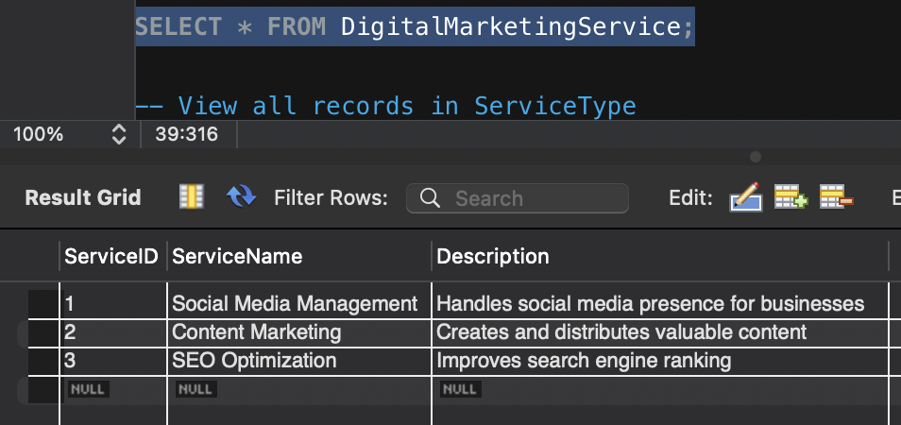

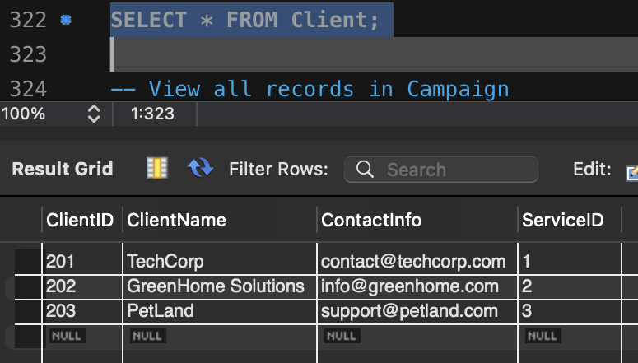

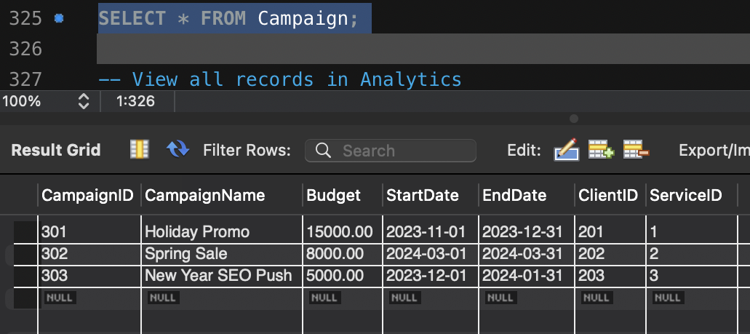

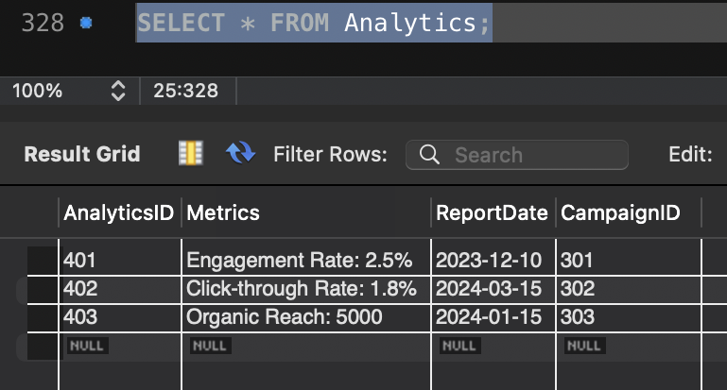

Delete Code:

-- Delete a record from DigitalMarketingService

DELETE FROM DigitalMarketingService

WHERE ServiceID = 5;

-- Delete a record from ServiceType

DELETE FROM ServiceType

WHERE TypeID = 106;

-- Delete a record from Client

DELETE FROM Client

WHERE ClientID = 205;

-- Delete a record from Campaign

DELETE FROM Campaign

WHERE CampaignID = 305;

-- Delete a record from Analytics

DELETE FROM Analytics

WHERE AnalyticsID = 405;

